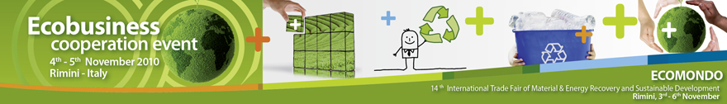

Ecobusiness cooperation event

Rimini 4 – 5 novembre 2010
www.b2match.com/ecomondo2010

IMPRESA: ______________________________________________________________________

RIFERIMENTO: _________________________________________________________________

INDIRIZZO: ___________________________________________________CAP_____________

CITTA’: ________________________________________________________________________

E-MAIL: _______________________________________________________________________

WEB: __________________________________________________________________________

CEL: ______________________________________________________________

TEL: __________________________________________________________________________

FAX: __________________________________________________________________________

SETTORE: _____________________________________________________________________

Vi invitiamo a compilare la scheda di manifestazione d’interesse sopra riportata e ad inviarla a promozione.bridgeconomies@mondimpresa.it oppure eventi@mondimpresa.it
Tel. 06 777 13 302 – 06 777 13 316

